|  |  |
| --- | --- |
| **Total Marks:** | **7.5** |
| **Obtained Marks:** |  |

**DATA STRUCTURE**

**AND**

**ALGORITHM**

**Lab Report # 04**

**Submitted To: Mam Tehreen**

**_____________________________________________________________________________________________________________________________________________________________________________________________________________________________________**

**Submitted By**: **Hammad Qureshi**  .

**Reg. Numbers: 2112114**

**______________________________________________________________________________________________________________________________________________________________________________________________________________________________________**

**Question no 1:**

1. **Swap nodes in a linked list without swapping data**
2. **Write a function that counts the number of times a given int occurs in a Linked List.**
3. **Write a function Linked list traversal using recursion in c++.**

**Code:**

|  |
| --- |
| **Part (a)**  #include<iostream>  using namespace std;    /* A linked list node */  class Node {  public:  int data;  Node* next;  };    /* Function to swap nodes x and y in linked list by  changing links */  void swapNodes(Node** head_ref, int x, int y)  {  // Nothing to do if x and y are same  if (x == y)  return;    // Search for x (keep track of prevX and CurrX  Node *prevX = NULL ,*currX = *head_ref;  while (currX && currX->data != x)  {  prevX = currX;  currX = currX->next;  }    // Search for y (keep track of prevY and CurrY  Node *prevY = NULL, *currY = *head_ref;  while (currY && currY->data != y) {  prevY = currY;  currY = currY->next;  }    // If either x or y is not present, nothing to do  if (currX == NULL || currY == NULL)  return;    // If x is not head of linked list  if (prevX != NULL)  prevX->next = currY;  else // Else make y as new head  *head_ref = currY;    // If y is not head of linked list  if (prevY != NULL)  prevY->next = currX;  else // Else make x as new head  *head_ref = currX;    // Swap next pointers  Node* temp = currY->next;  currY->next = currX->next;  currX->next = temp;  }    /* Function to add a node at the beginning of List */  void push(Node** head_ref, int new_data)  {  /* allocate node */  Node* new_node = new Node();    /* put in the data */  new_node->data = new_data;    /* link the old list off the new node */  new_node->next = (*head_ref);    /* move the head to point to the new node */  (*head_ref) = new_node;  }    /* Function to print nodes in a given linked list */  void printList(Node* node)  {  while (node != NULL) {  cout << node->data << " ";  node = node->next;  }  }    /* Driver program to test above function */  int main()  {  Node* start = NULL;    /* The constructed linked list is:  1->2->3->4->5->6->7 */  push(&start, 7);  push(&start, 6);  push(&start, 5);  push(&start, 4);  push(&start, 3);  push(&start, 2);  push(&start, 1);    cout << "Linked list before calling swapNodes() ";  printList(start);    swapNodes(&start, 4, 3);    cout << "\nLinked list after calling swapNodes() ";  printList(start);    return 0;  }  **Part (b)**  #include<iostream>  using namespace std;    /* Link list node */  class Node {  public:  int data;  Node* next;  };    /* Given a reference (pointer to pointer) to the head  of a list and an int, push a new node on the front  of the list. */  void push(Node** head_ref, int new_data)  {  /* allocate node */  Node* new_node = new Node();    /* put in the data */  new_node->data = new_data;    /* link the old list of the new node */  new_node->next = (*head_ref);    /* move the head to point to the new node */  (*head_ref) = new_node;  }    /* Counts the no. of occurrences of a node  (search_for) in a linked list (head)*/  int count(Node* head, int search_for)  {  Node* current = head;  int count = 0;  while (current != NULL) {  if (current->data == search_for)  count++;  current = current->next;  }  return count;  }    /* Driver program to test count function*/  int main()  {  /* Start with the empty list */  Node* head = NULL;    /* Use push() to construct below list  1->2->1->3->1 */  push(&head, 1);  push(&head, 3);  push(&head, 1);  push(&head, 2);  push(&head, 1);    /* Check the count function */  cout << "count of 1 is " << count(head, 1);  return 0;  }  **Part (c)**  #include<iostream>  using namespace std;  struct Node {  int data;  Node* next;  };    // Allocates a new node with given data  Node *newNode(int data)  {  Node *new_node = new Node;  new_node->data = data;  new_node->next = NULL;  return new_node;  }    // Function to insert a new node at the  // end of linked list using recursion.  Node* insertEnd(Node* head, int data)  {  // If linked list is empty, create a  // new node (Assuming newNode() allocates  // a new node with given data)  if (head == NULL)  return newNode(data);    // If we have not reached end, keep traversing  // recursively.  else  head->next = insertEnd(head->next, data);  return head;  }    void traverse(Node* head)  {  if (head == NULL)  return;    // If head is not NULL, print current node  // and recur for remaining list  cout << head->data << " ";    traverse(head->next);  }    // Driver code  int main()  {  Node* head = NULL;  head = insertEnd(head, 6);  head = insertEnd(head, 8);  head = insertEnd(head, 10);  head = insertEnd(head, 12);  head = insertEnd(head, 14);  traverse(head);  } |

**CONSOLE SCREEN:**

**Part(a)**

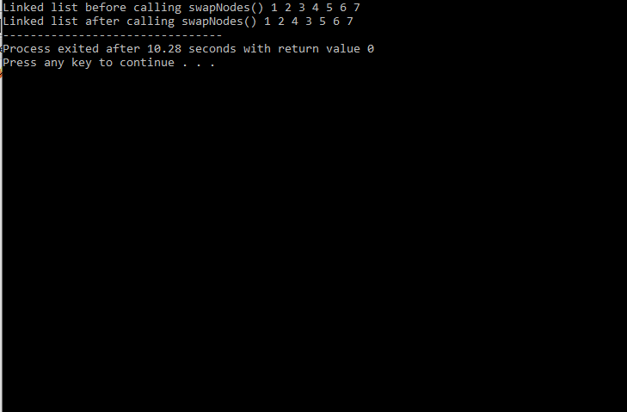

**Part(b)**

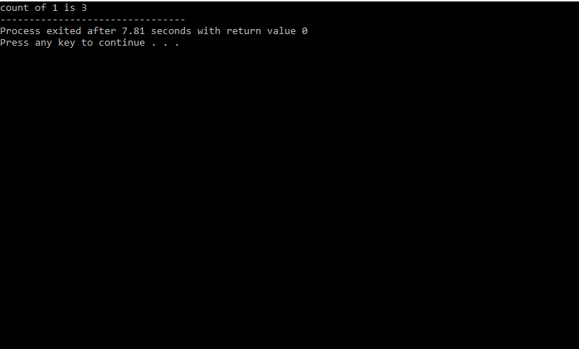

**Part(c)**

